­

Aiza Islam 343201

Maaz Ahmad 335009

Shehryar Saqib 347703

Uswa Fatima 335135

**RTG – Ready to Go Travels**

2020

Submitted by:

PROJECT REPORT for a TRAVEL AGENCY

*CS344 Web Engineering Project*

**Abstract:**

RTG (Ready to Go) Travels is a travel agency devoted to providing the best possible experience to its users. It is an online travel booking website that provides comprehensive information about the offered destinations, the best itineraries, top-notch amenities, and an unforgettable experience all while giving the users the ability to book tours online without any hassle. For the cs350 Web Engineering project, the aim of the group was to design and build a cutting-edge, professional website for this travel agency. Using this website, the users will be able to sign up, book tours from a list of pre-prepared travel packages or customize a travel package that is tailored to their needs. Moreover, the travelers can explore the website to gain assistance for planning their next trip. The responsive script and layout have been designed through HTML, CSS and Bootstrap v.5.2.3. The server-side programming has been achieved through php and Laravel with the database records stored in a mysql database.

**Motivation:**

The tourism industry, also known as the travel industry relies heavily on the beauty of travel destinations to attract customers. But for any business to survive in today’s competitive market, it requires a strong online presence. Any travel agency also requires its own online presence in the form of a specialized website since customers are interested in exploring every location on their own without any intervention of travel operators.

For any travel agency to have its own specialized website with all its touring listings, provides credibility for the company. In this way, the company has its own portal where all the visitors are potential clients hence providing a brand personalization. Some of the best travel sites also include a blog section where they introduce information the travellers require. The content may refer to information related to places of interest, historical and cultural monuments and tourist attractions to pique the visitors’ interest.

Among the plethora of travel agencies offering their services online, the number of companies operating online in Pakistan is fairly less. Amongst these agencies, no one provided the whole information that keen travelers require as they plan to explore the country. Many agencies are glad to merely introducing profile pages on social media platforms. This is where RTG emerges as an impressive competitor in the market.

Instead of relying on a mere social media presence, the goal is to present a user-friendly website for RTG to guide the travellers and ensure them of the legitimacy of the company. The site uses visual content like photos and videos to attract more attention of the visitors and transmit meanings faster than texts. Itinerary details including every detail about different spots in the destinations have been covered that the customers can check and verify before they confirm their booking. Saving people from the hassle of confirming bookings over the phone, online booking system has been presented. Since people trust others who have experience in working with a company more than the company itself, The FAQ and testimonials sections is there to help. Moreover, the website design is responsive, user-friendly, and very easy to use. The customized tour option aims to provide a more customized experience to the users.

**Responsive Layout:**

Bootstrap v.5.2.3 and media queries have been employed to render a responsive website.  
Moreover, all the text and the images are dictated by relative units i.e., they change size according to the changes in screen sizes. Hence, a responsive website layout has been achieved that works efficiently on all kinds of devices and all kinds of screen sizes. The website behavior across a few screen sizes is demonstrated below:

* Nest Hub Max (1280 x 834)

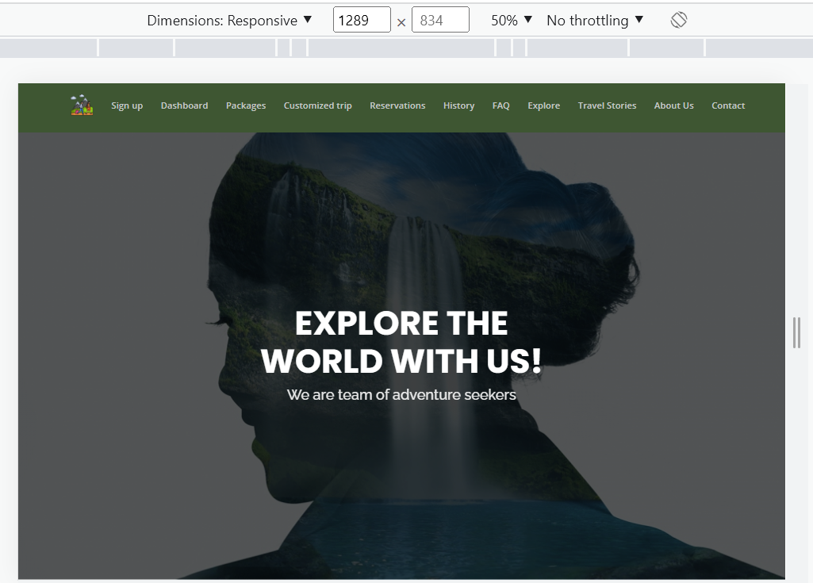

* iPad Air (820 x 1180)

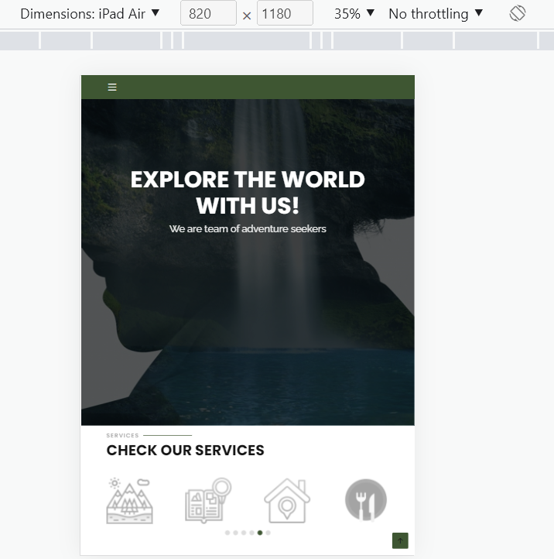

* Samsung Galaxy S8+ ( 360 x 740)

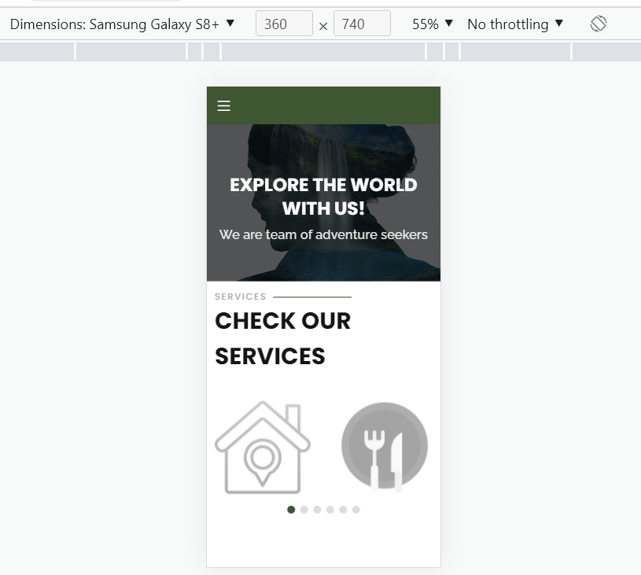

So, RTG has a clean and modern design created with Bootstrap framework, with animation on-scroll effects, smooth navigation and links scroll and cross browser compatibility. The website’s home page is developed in a way that it summarizes the complete idea of our website in the first look, with a hero section, and a slider listing the services we provide right below it. Using the options available in the header section, the user can navigate to other pages within the website. These include the tour packages section, customized pages, explore feed, contact information and much more.

**Type of content:**

The RTG website typically provides information about destinations, attractions, and activities for travelers. It is a platform that provides information about different tourist destinations, attractions, activities, and accommodations in Pakistan while offering booking and reservation services for flights, hotels, tours, and other travel-related services. The content on a tourism website is typically organized into sections and subsections to make it easy for users to find the information they are looking for. The main purpose of this platform is to help travelers plan and book their vacations or business trips with a wide range of information and resources, such as maps, photos, videos, reviews, and itineraries, to help visitors make informed decisions about where to go and what to do.

**ADMIN/USER**

In the website, the term admin refers to the person who have administrative privileges and can manage the website's content and settings. These privileges include the ability to view every possible reservations, add and remove users, and access and modify the website's database along with the reviews of visitors. The website has a more open and interactive structure, allowing users to contribute content or engage with the site in other ways such as uploading a review, deleting own reservations etc. The users mode refers to the people who visit the website and may have the ability to interact with the site in some way. For example, users can post reviews, customize own trips, select builtin packages and contact the authorized personalities.

The RTG website platform divides the admin and user functionalities in a unique manner. The admin credentials are saved in the database in already existing user table with a boolean differentiating them from normal users. A visitor can only view few web pages such as index page, advertisement, explore, about us and contact page, any attempt to access the rest of the pages will redirect the visitor to the login page. To explore the rest of the website, the visitor will need to authenticate itself by registering an account accordingly. The admin can view every booked trip in the dashboard and can also check the reviews uploaded by the users in FAQ page with privileges to delete them as well.

**PACKAGES**

Relying on the packages, the basic structure of the website is all about the built-in and customized packages along with their key differences. Both possibilities can be only accessed the already registered user. The built-in packages refer to pre-designed and pre-priced travel packages that are offered by the website and affiliated travel providers which include a combination of transport, hotel,

tour, and other related services, and are typically designed to appeal to a wide range of travelers. The built-in packages are stored in the database dynamically displayed on the website, which are updated by the administration with time. An example that can be referred is the upcoming Kashmir trip departing on 23rd of December and returning on 25th December with price of 15000 PKR per person.

Customized packages, on the other hand, are tailor-made travel packages that are created to meet the specific needs and preferences of an individual traveler or group. Customized packages can be created by our customers.

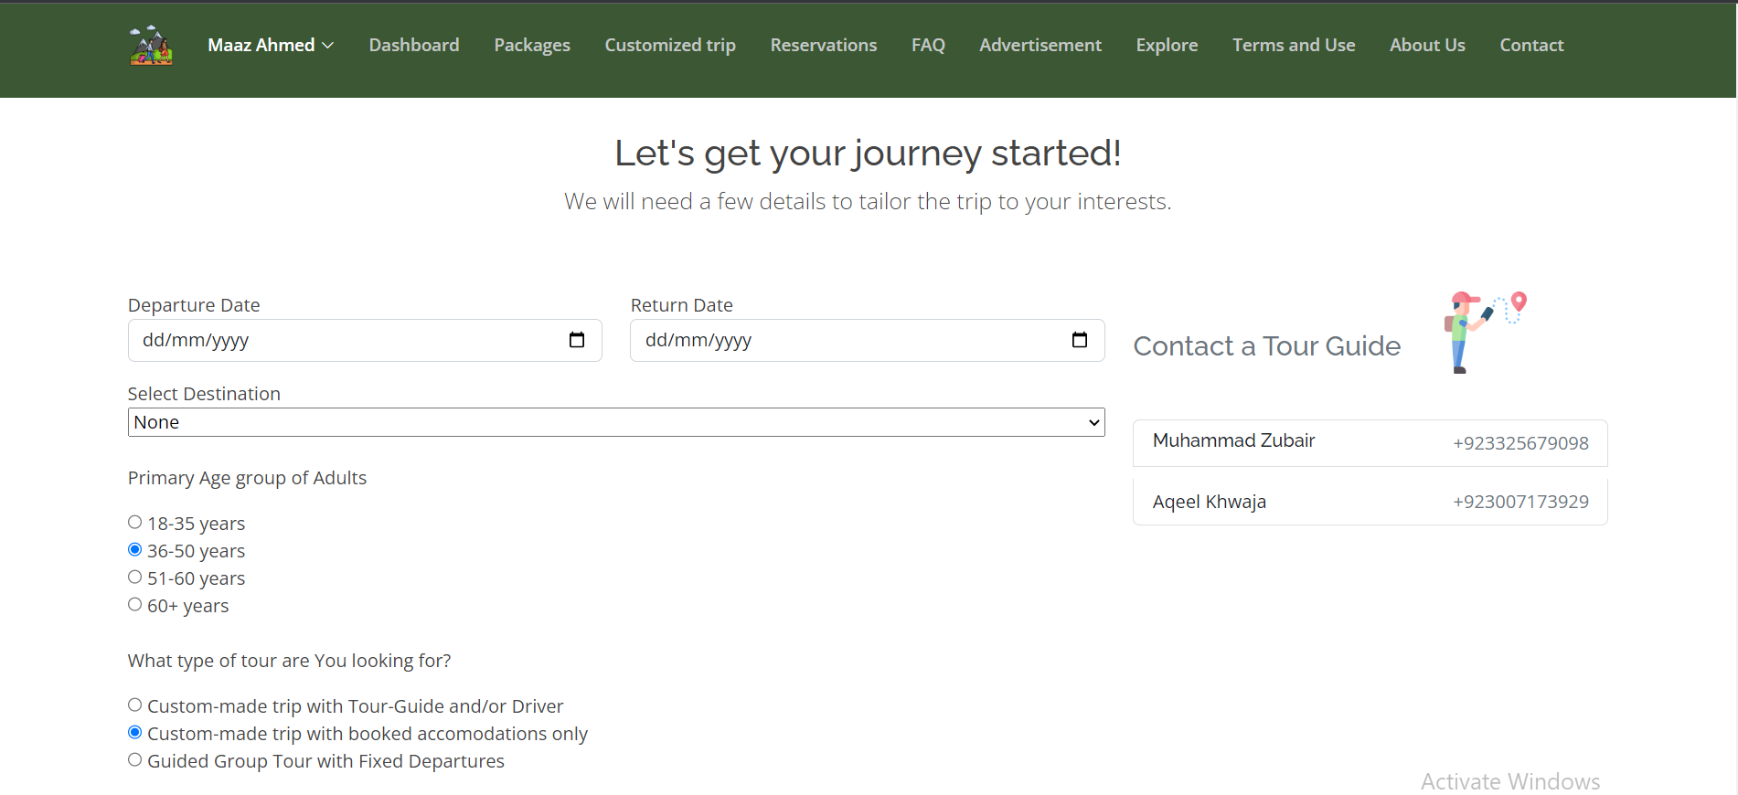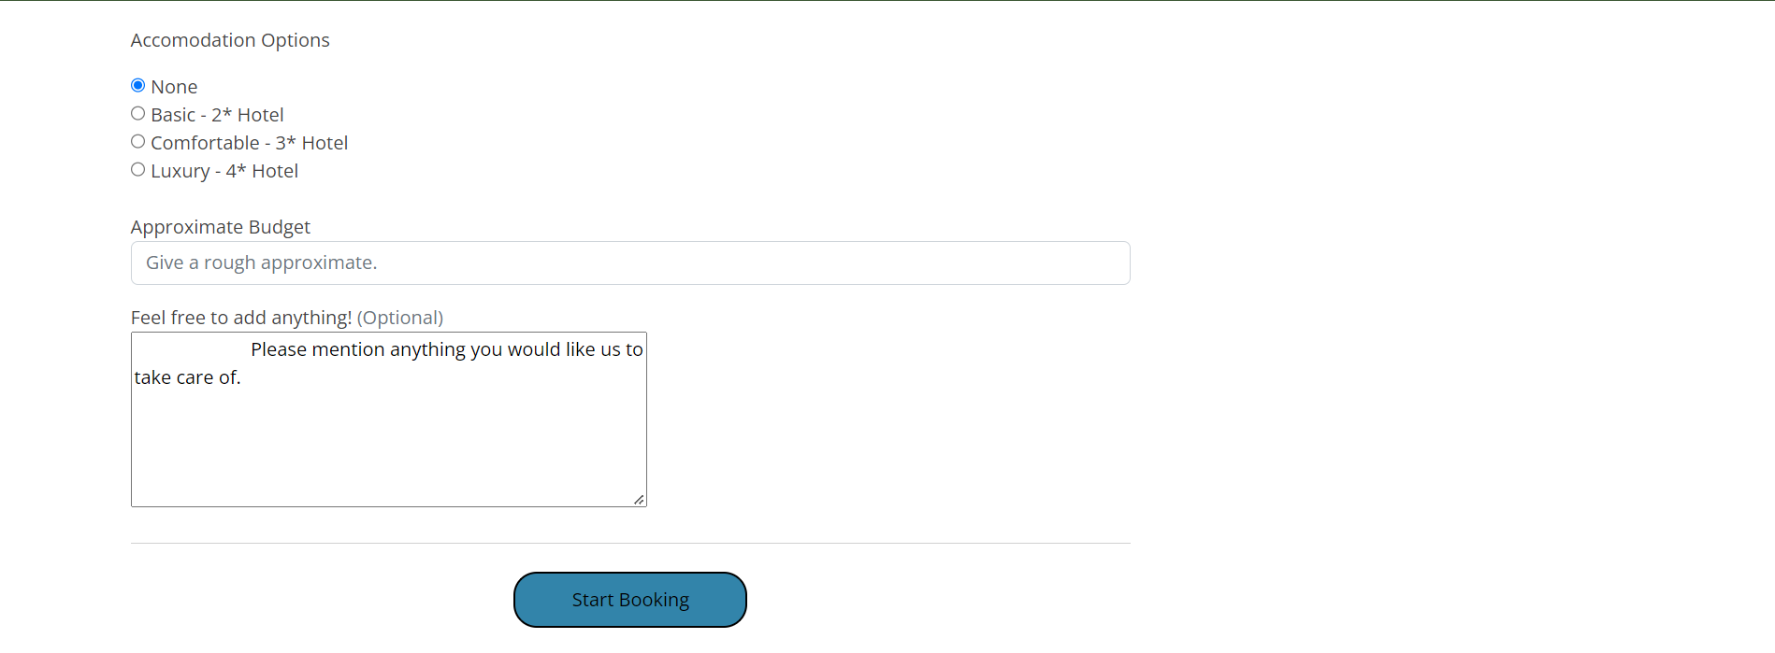

There are a few key differences between choosing built-in packages and customized packages on a tourism website:

* Flexibility: Built-in packages are generally less flexible than customized packages, as they are pre-designed and pre-priced. Customized packages, on the other hand, can be tailored to the specific needs and preferences of the customer, allowing for more flexibility in terms of destinations, activities, and accommodations.
* Cost: Built-in packages may be less expensive than customized packages, as they are typically designed to appeal to a wide range of travelers and may be priced competitively. Customized packages, on the other hand, may be more expensive, as they are tailored to the specific needs and preferences of the customer and may include higher-priced options.
* Time and effort: Choosing a built-in package may require less time and effort on the part of the traveler, as the package has already been designed and priced. Customized packages, on the other hand, may require more time and effort to create and finalize as the suggested budget must be approved before being labelled as user’s reservation.

No matter which option the user goes with, both built-in and customized packages are redirected to bookings page which requires the user to fill essential details, later uploaded on the database and displayed in the user’s reservations page.

**Organization:**

Typically organized to provide easy access to information and resources for travelers planning vacations or business trips, the RTG website is a highly maintained platform with a greater scope targeting larger audience. Every webpage includes a navigation bar and a footer. The navigation bar differs for the users and admins while the footer remains the same.

The website is organized around a main menu or navigation bar that allows visitors to access different sections of the site. The sections included are:

* Home/Dashboard: This is the main landing page of the website, which features a banner, tempting offers of checking out the services and highlights featured destinations.
* Packages: This section of the website offer a range of pre-designed and pre-priced travel packages, including combinations of transport, hotels, tours, and other related services.
* Customized Trips: This page offers and allows the user to book a customized trip by choosing the location, departing and returning time, the number of people and other details with approximate budget later to be approved or rejected.
* Reservations: This section shows the current reserved trips of the authenticated user.
* Advertisement: The page depicting company’s previous tours, tempting offers and answer to a question of ‘Why Us?’.
* Explore: A report-based web page with a form in the end requiring name and email of the guest user, allowing him to subscribe to the company’s newsletter and stay up to date with latest travelogue stories.
* About Us: This section explains the identity and the standards the company stands on.
* Contact: This section typically includes contact information for the website and its partners, as well as a form for users to submit inquiries or requests.

**Pages of the website:**

**Login and Sign Up:**

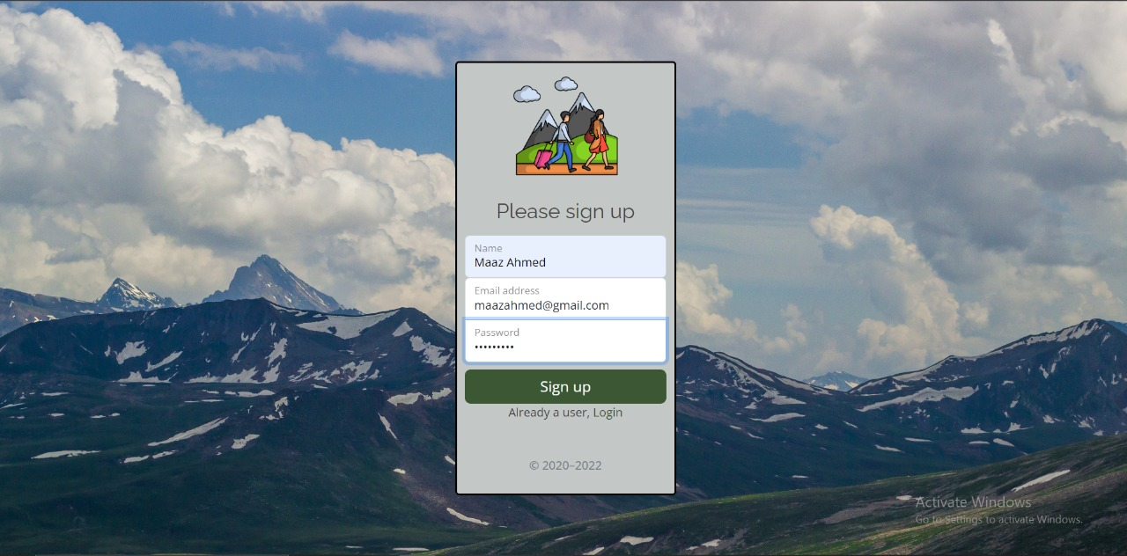

The login and sign up feature of this website allows users to create an account on the website and access restricted content or services. The sign up process involves filling out the full name, email and password. Once a user has created an account, they can use the login feature to access their account and gain access to restricted content. To log in, enters their email and password on a login form and submits it to the website. If the login credentials are correct, the user will be granted access to their account.

**Customer Dashboard:**

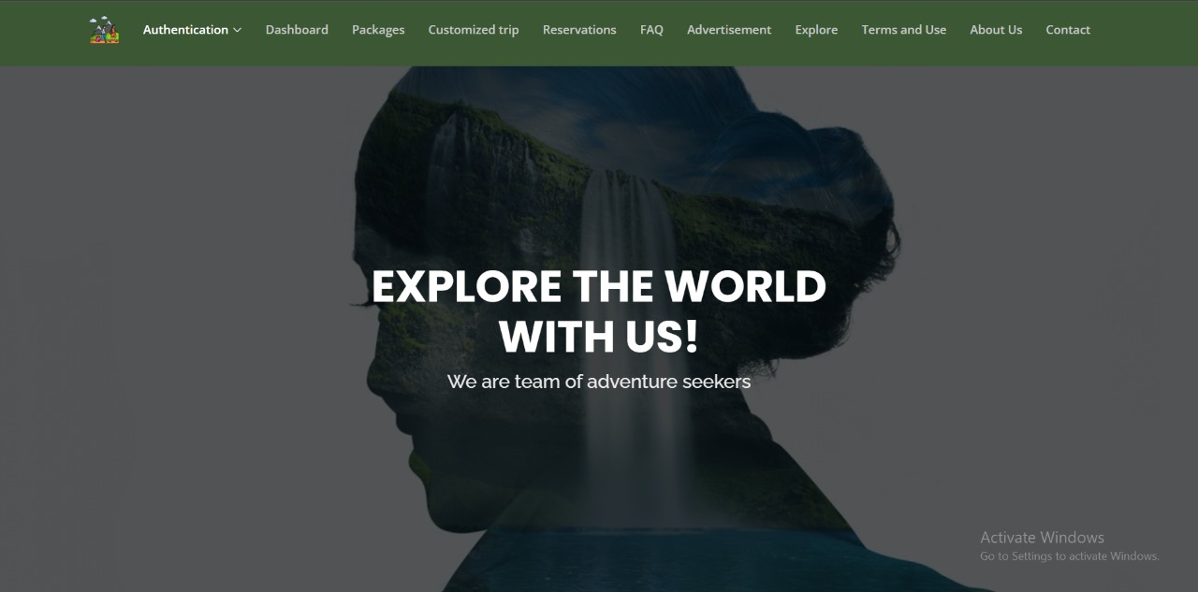

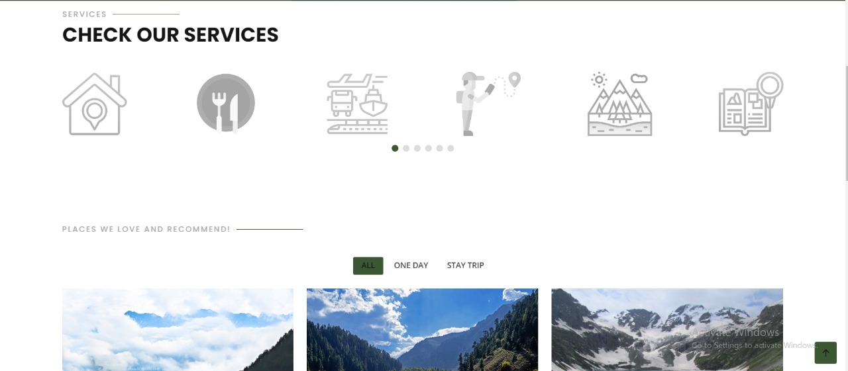

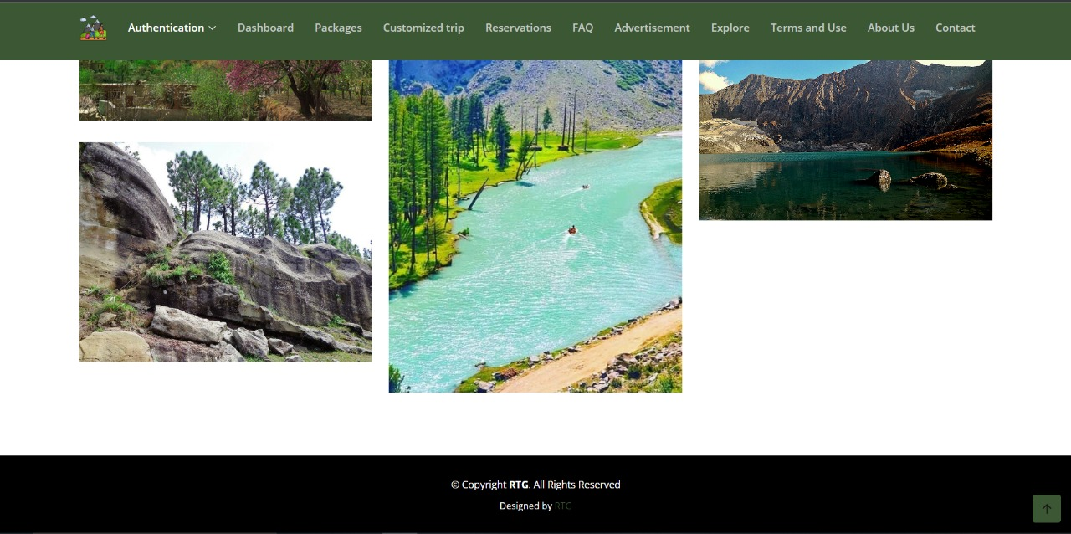

The index page (also known as the homepage) of our travel agency website is the first page that users see when they visit the site. It serves as a gateway to the rest of the website and provides an overview of the agency's services and offerings.

The elements that found on the index page of are given below:

* A navigation menu: This allows users to access different areas of the website, such as reservations, packages, and FAQ.
* Services: This allows the agency to build a reliable image by giving an overview of the services.
* A list of popular destinations or packages: This showcases some of the agency's top-selling or most popular offerings.
* A footer This is a section at the bottom of the page that typically includes links to important pages on the website, such as the terms of use and privacy policy.

**Packages:**

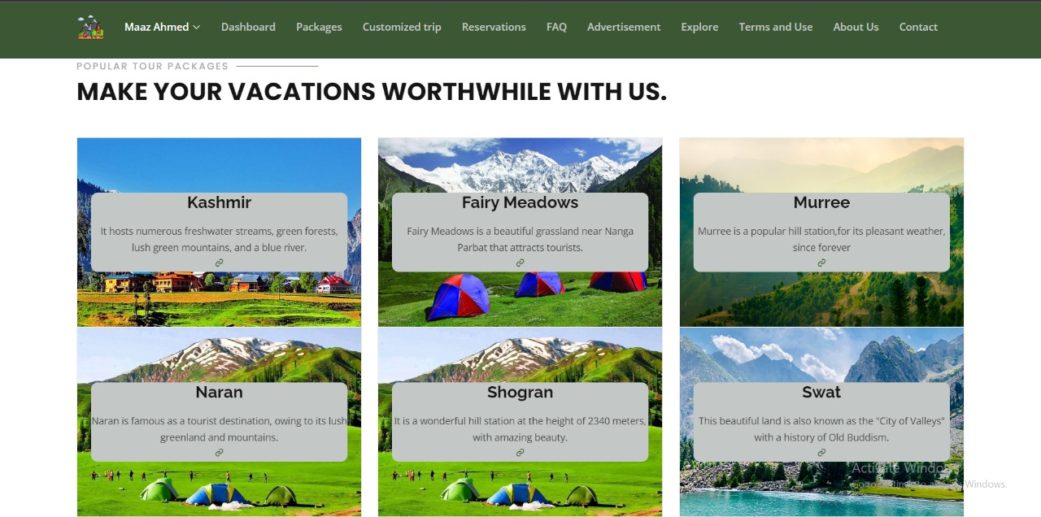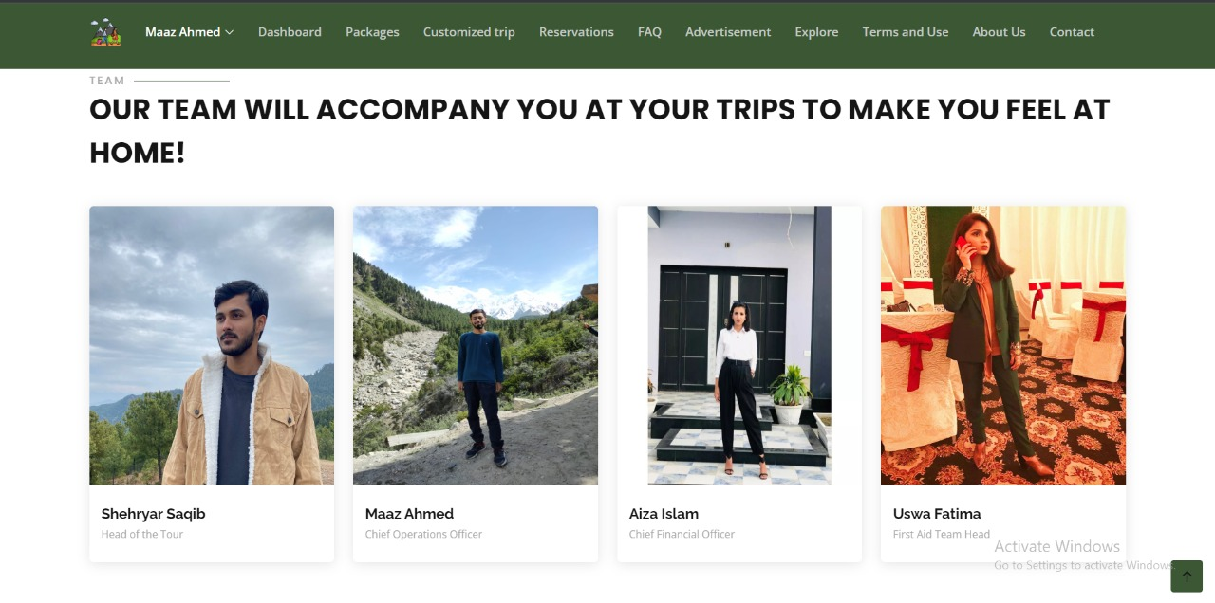

The packages page of our travel agency website is a page that lists the various travel packages that the agency offers. The packages are listed along with the images for each package, a brief description and call to action (CTA) - that is a link that encourages users to book a package or learn more about it. The team members and owners of the agency are also introduced to give the website a friendly reputation.

**Package Details:**

There are total six packages currently enlisted and each package has a separate page to give a detailed overview. One of those pages are given below as example:

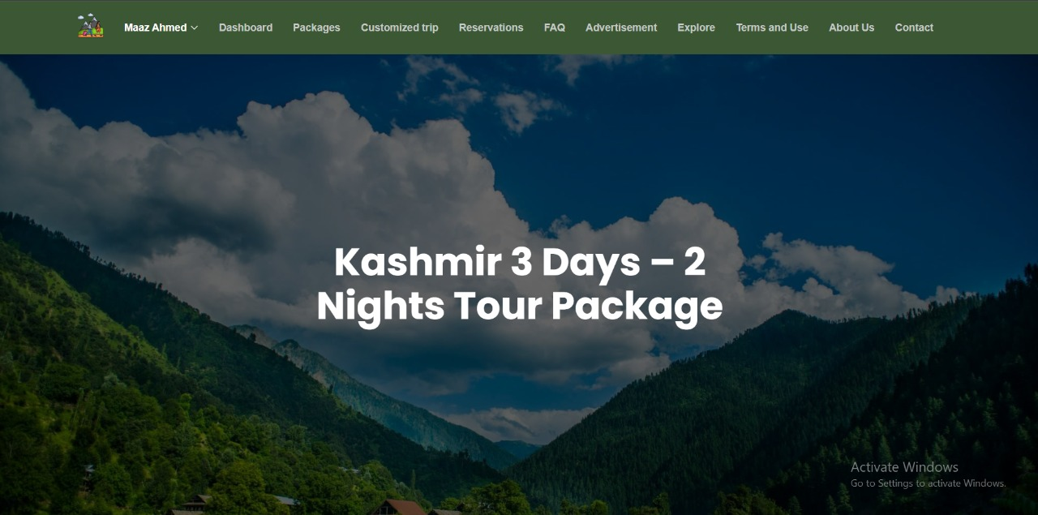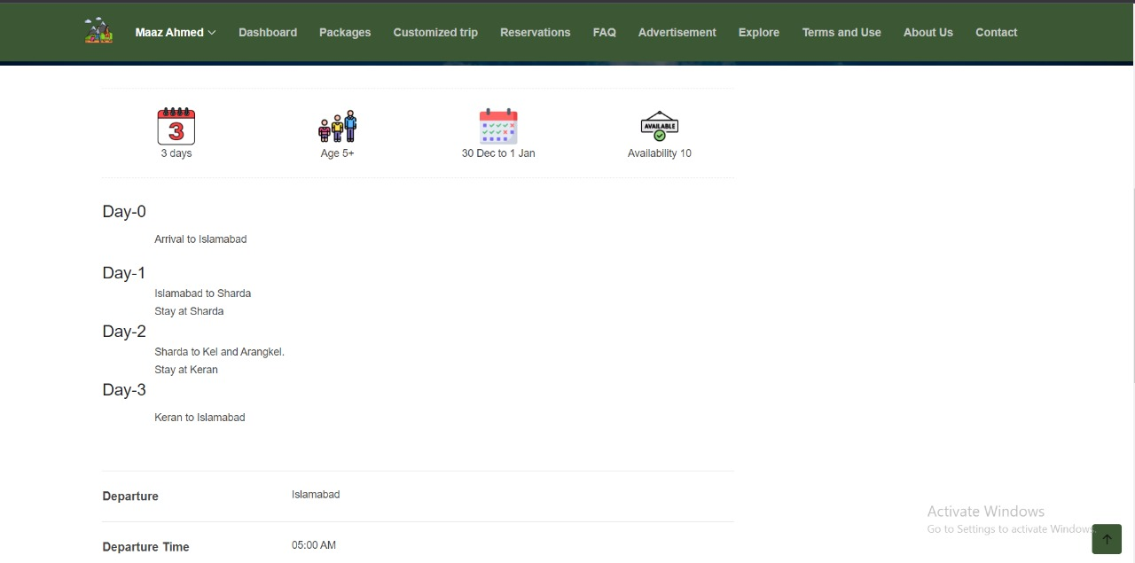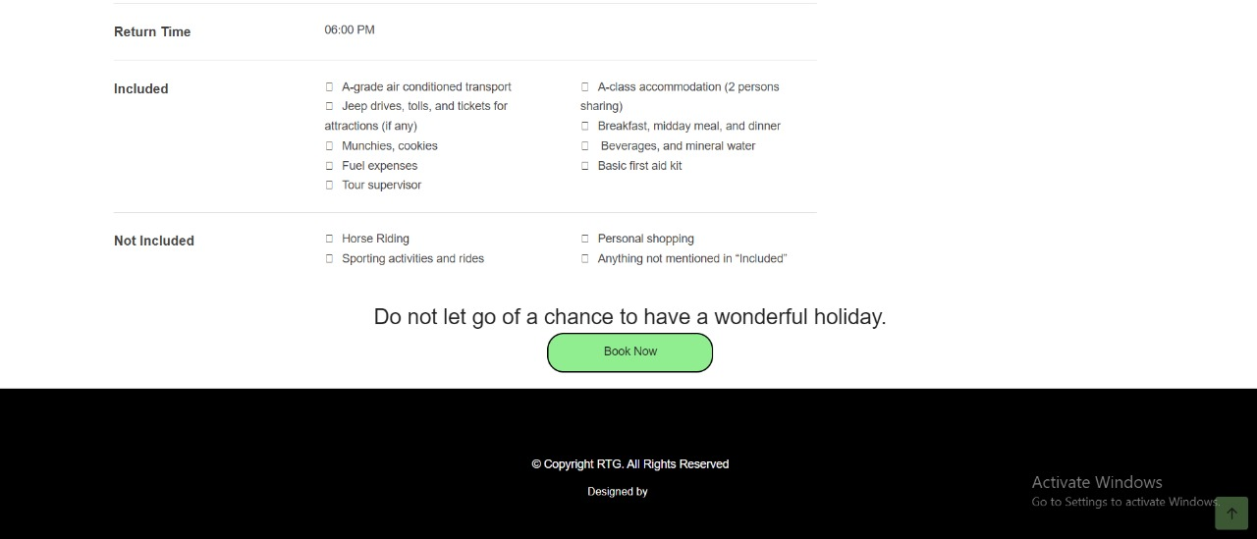

This page provides detailed information about a specific travel package offered by the agency. This information can help users understand what is included in the package and make an informed decision about whether to book it.

The elements included in the package details page are given below:

* Package name: This is a brief, descriptive title for the package.
* Destination: This is the location where the package is based, such as Kashmir, Shogran.
* Inclusions: This is a list of what is included in the package, such as flights, accommodations, meals, activities, and tours.
* Itinerary: This is a detailed schedule of what is included in the package, day by day.
* Price: This is the cost of the package, including any taxes and fees.
* Duration: This is the length of time that the package is valid for.
* Book Now: This is a button that encourages users to book the package. Upon clicking this button the website directs to a booking form.

**Customized Trip:**

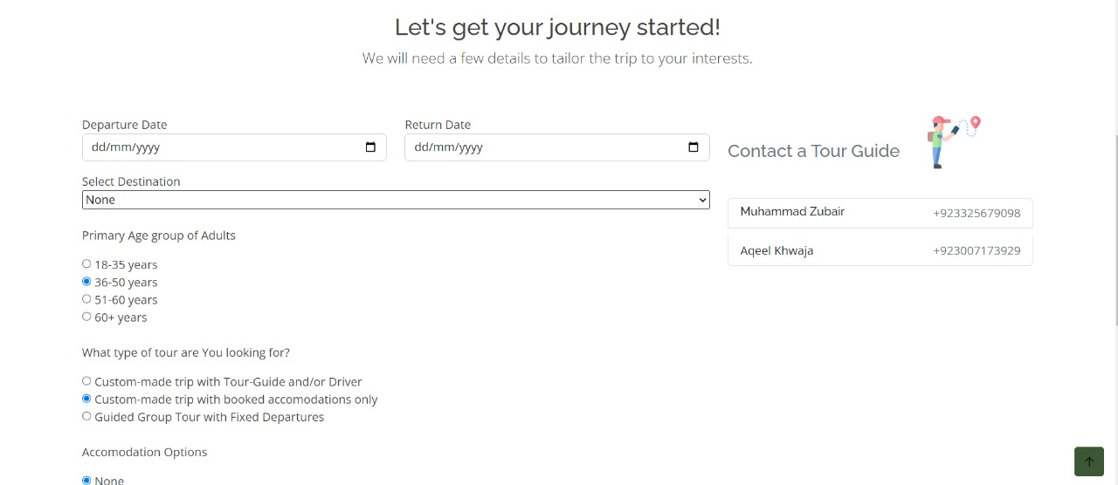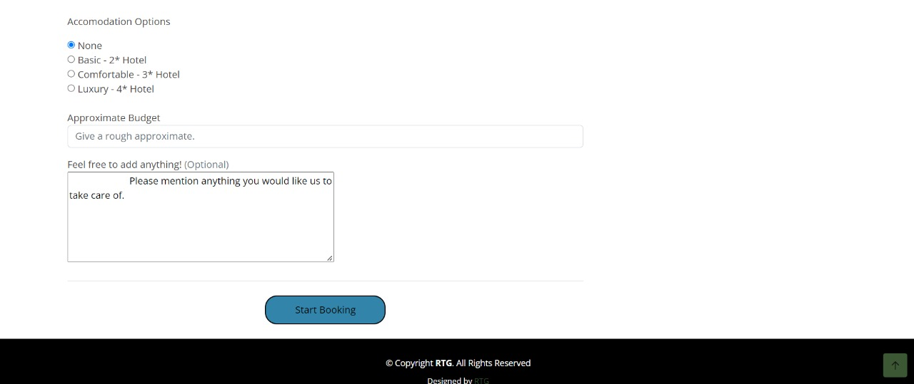

It is a form that allows users to create their own custom travel packages based on their specific preferences and requirements. The form includes a series of fields that the user must complete, such as their personal and contact information, the details of their travel plans, and payment information.

This includes the following:

* Personal information: This includes fields for the user's name, email address, and phone number.
* Travel details: This includes fields for the destination, dates of travel, number of travelers, and other preferences.
* Package details: This includes information about the flights, accommodations, activities, and tours that are included in the custom package.
* A submit button: This is a button that the user must click to submit the form and complete the booking process.

**Booking:**

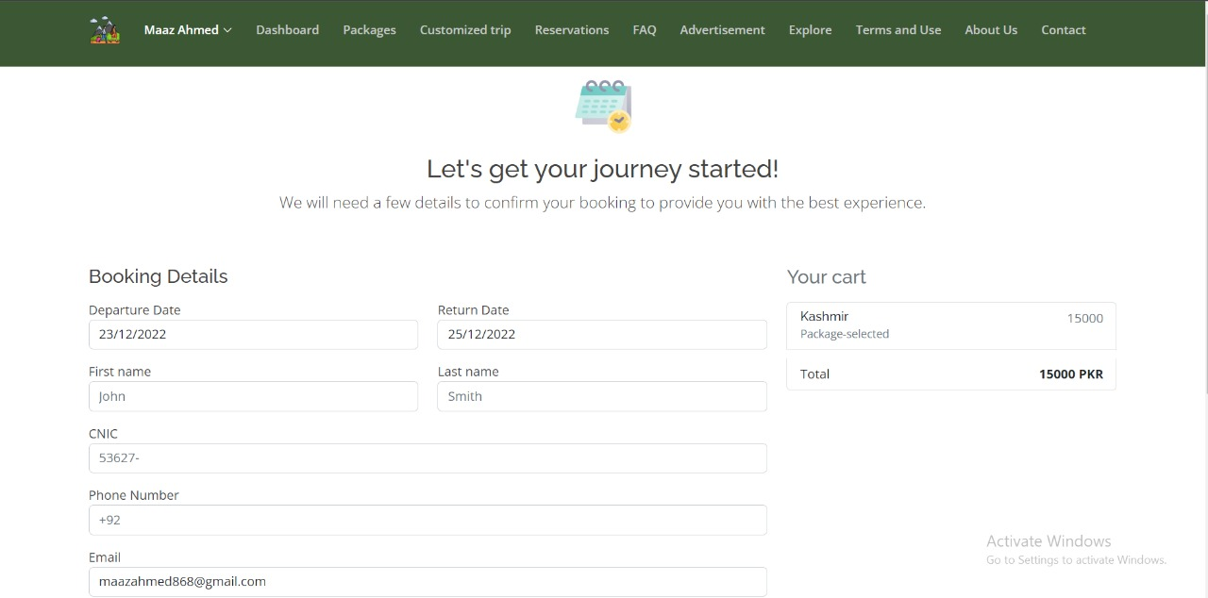

Users fill out this form to book a travel package.

This form includes:

* Personal information: This includes fields for the user's name, email address, and phone number.
* Payment information: This includes fields for the user's billing details.
* A submit button: This is a button that the user must click to submit the form and complete the booking process.
* Error messages: These are messages that appear if the user has made a mistake in completing the form in a wrong way.

**Confirmation Email:**

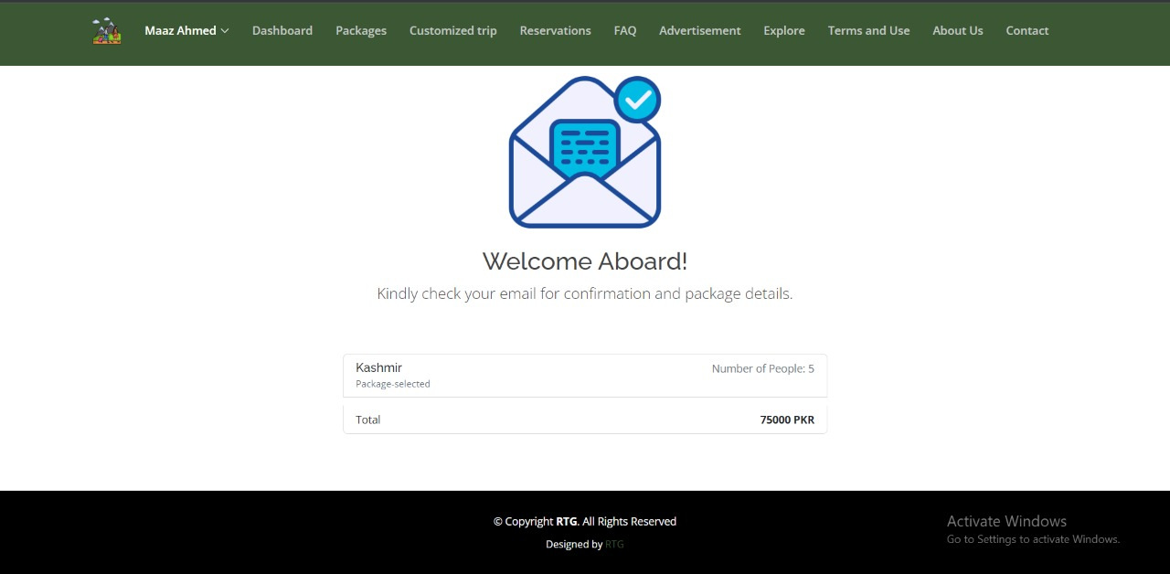

This is a page that appears after the form has been successfully submitted, confirming the details of the booking and providing further instructions and also sends the email to the user’s provided email with the details.

**Reservations:**

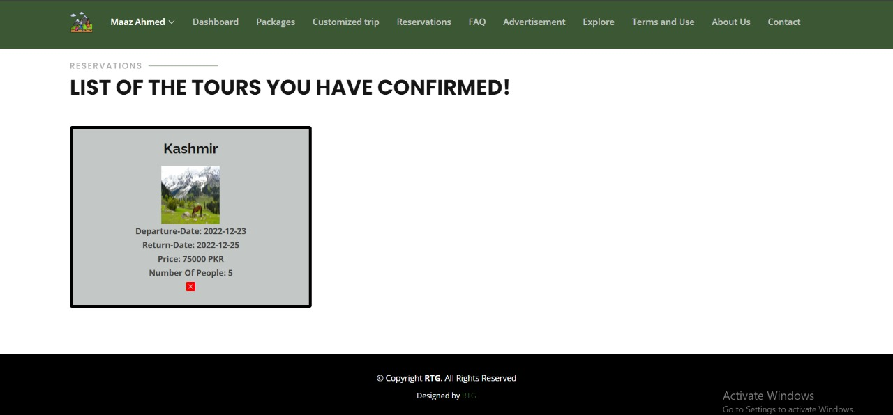

This page allows users to view and manage their bookings and reservations with the agency. This page displays a list of reservations, along with the related information about each reservation, such as the destination, dates, and cost. This also allows users to cancel their reservations.

**Reviews and FAQ:**

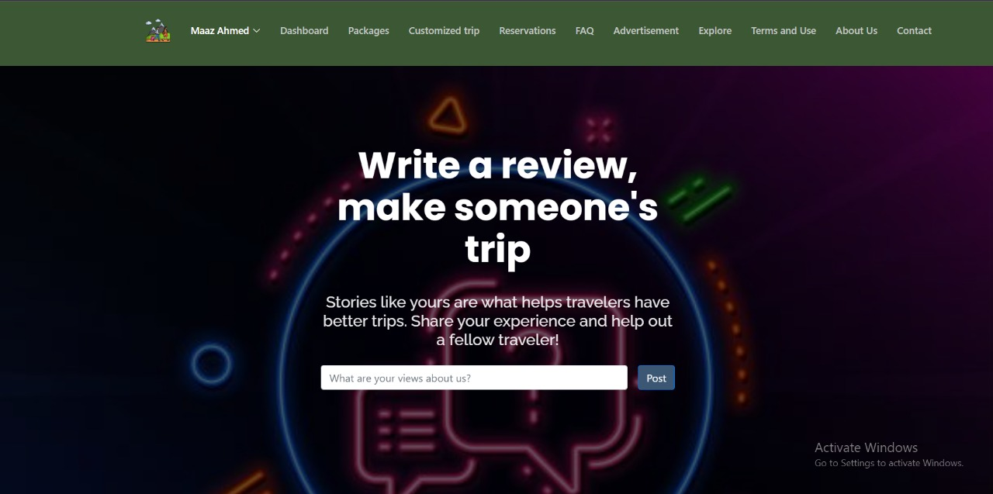

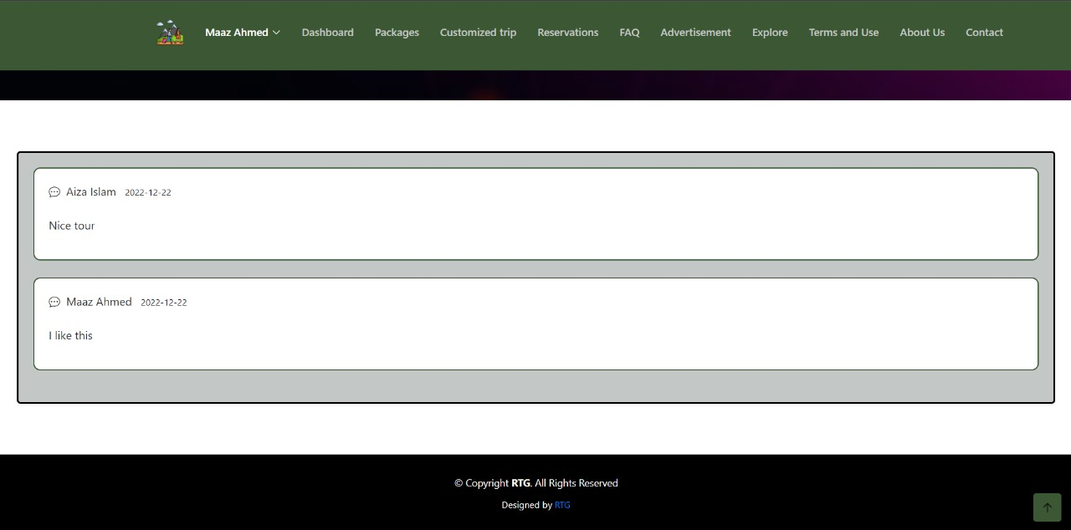

The review page includes customer reviews and ratings of the agency's services. These reviews can provide valuable insight and feedback to help users make informed decisions about whether to book with the agency. This gives the users option to post their own review.

**Advertisement:**

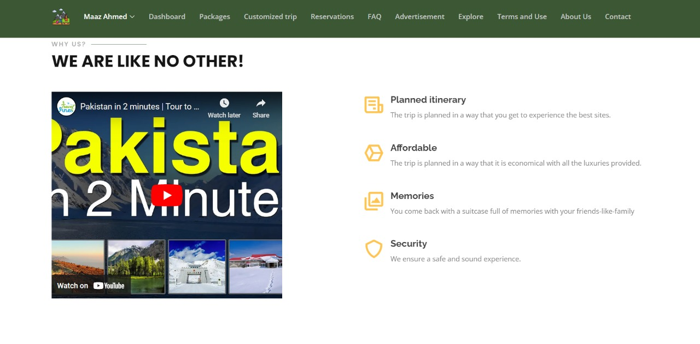

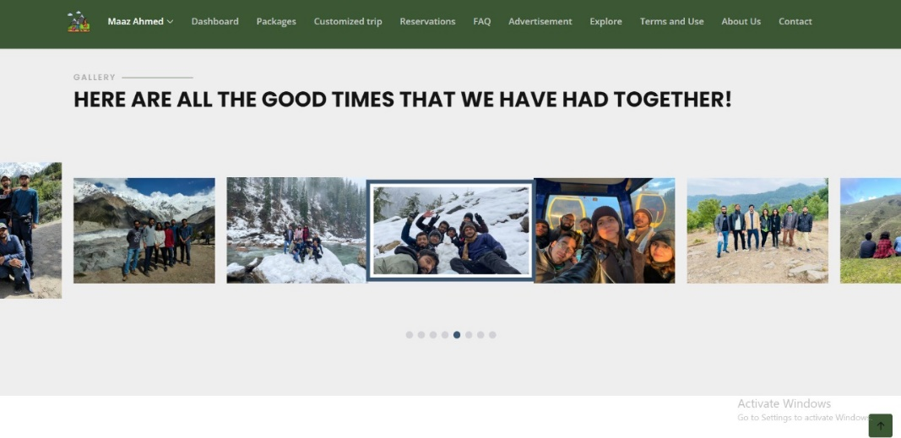

The advertisement page of a travel agency website is a page that showcases the various advertisements that the agency is currently running. These advertisements are targeted at specific users that might be interested to travel. The website supports a variety of ad formats, such as banner ads, display ads, video ads, and testimonial ads.

**Explore:**

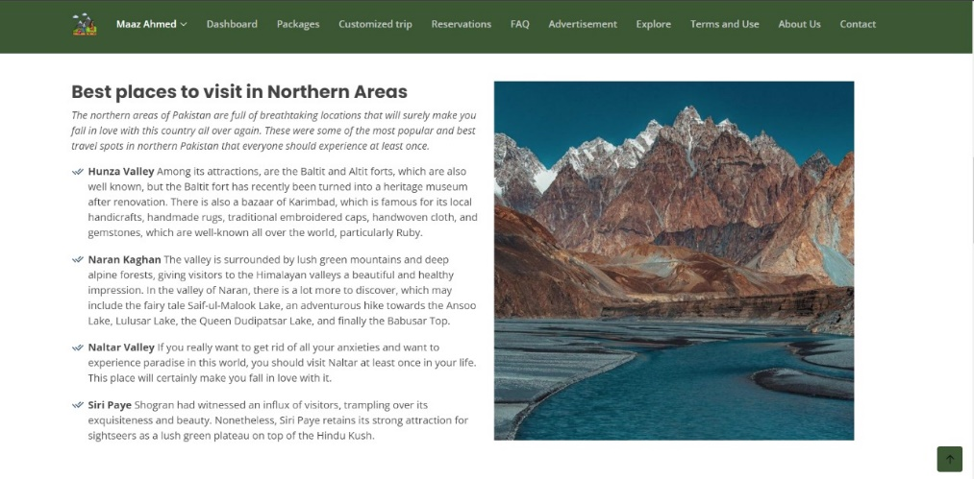 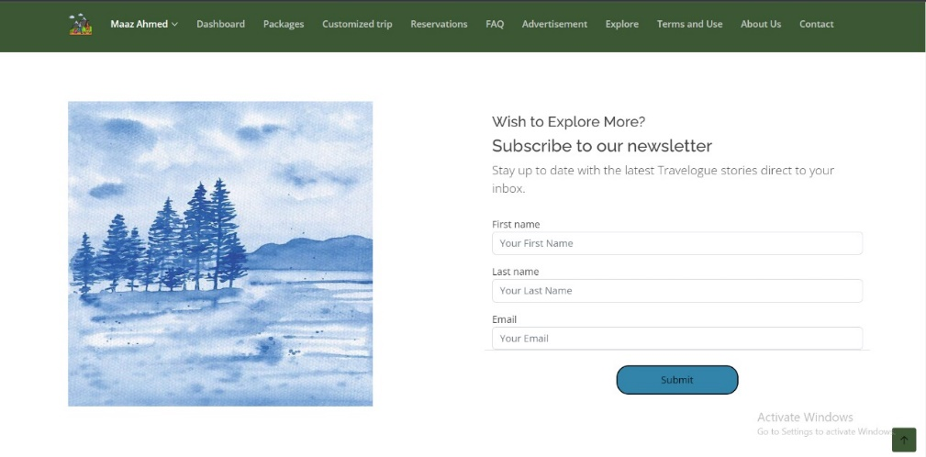

The is the page that allows users to discover and learn about different destinations and travel options offered by the agency. This page includes a wide range of information and resources to help users plan their travels, such as destination guides, travel tips, and recommendations. This includes advice

and suggestions for things to do, places to see, and ways to make the most of the destination making it more like a blog section that also gives users the option to subscribe to the newsletter of the website as well.

**Terms Of Use:**

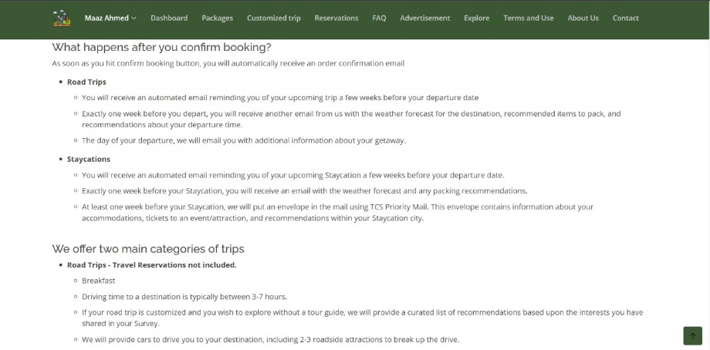

The terms and conditions page our agency website is a page that outlines the legal terms and conditions that apply to the use of the website and the agency's services. This page includes information about the rights and responsibilities of the agency and its users, as well as any limitations or exclusions of liability. his is a statement indicating which jurisdiction's laws apply to the terms and conditions.

**About Us:**

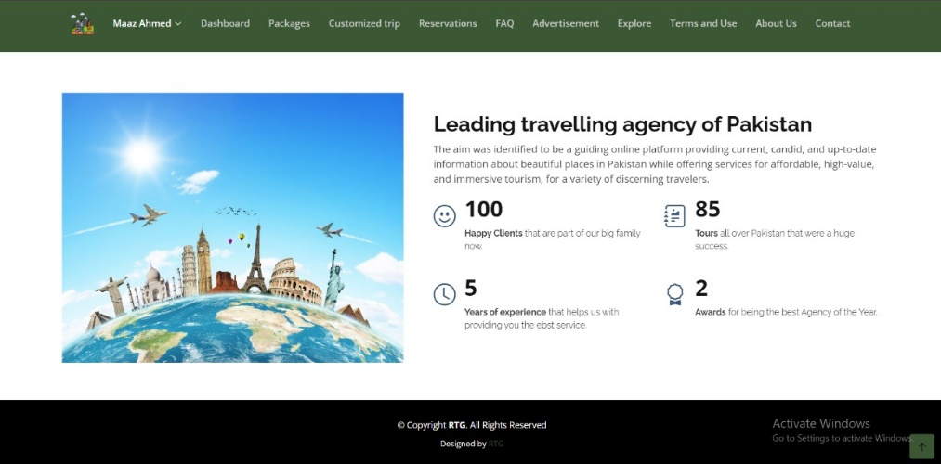

The about us provides information about the agency, its history, and its mission. This showcases any accolades or recognition that the agency has received. This is a visual representation of the agency's history, highlighting key milestones and achievements.

There is a summary of the agency's purpose and values and a description of the agency's long-term goals and aspiration

**Contact:**

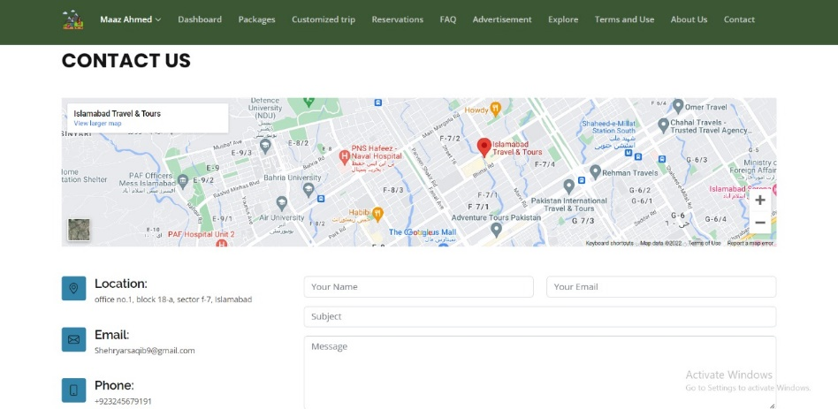

This page provides information about how users can get in touch with the agency. This page includes the agency's contact details; its phone number, email address, and physical address, as well as a contact form that users can fill out to send a message This is a form that users can fill out to send a message to the agency. The form typically includes fields for the user's name, email address, and message that will be send to the email of the admin.

**Admin Dashboard:**

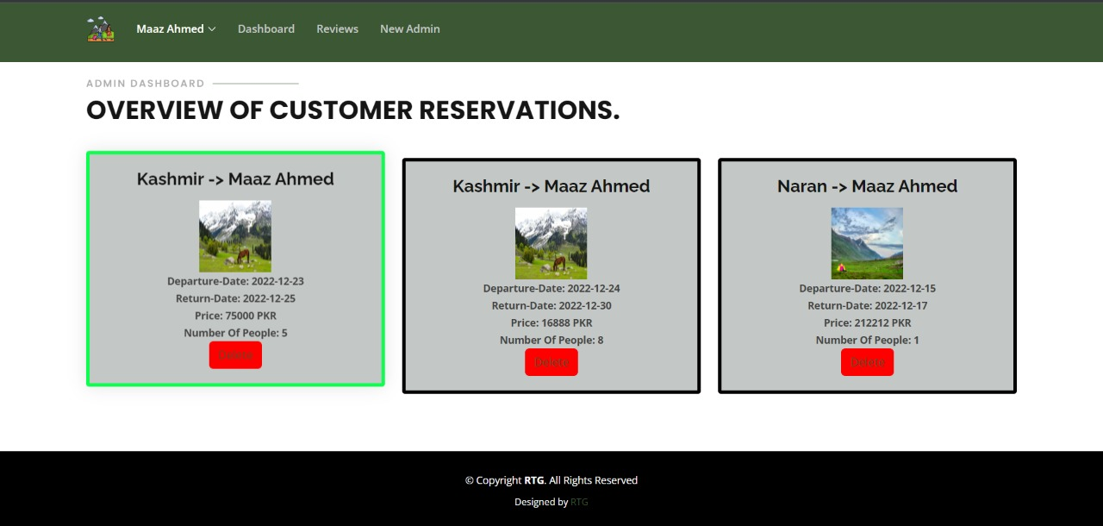

The admin dashboard is linked backend interface that allows the agency's staff to manage and view the reservations along with the user details. This is a summary of key metrics that the admin can see in the form of a comprehensive table. The admin approved the reservations they are being booked by the users in order to maintain the availability for a particular tour. The admin also approves the customized trip as per the expected budget.

**Reviews management:**

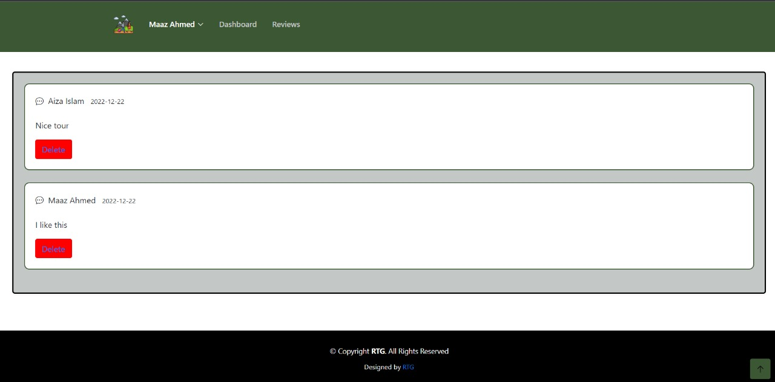

Review management by the admin for a travel agency website refers to the process of monitoring and managing customer reviews and ratings of the agency's services. This involves moderating the reviews to ensure that they meet the website's guidelines and standards, responding to customer feedback, and using the reviews to identify areas for improvement. Hence all of the reviews are shown to the admin and it gives admin the option to delete unethical reviews.

**Adding a new Admin:**

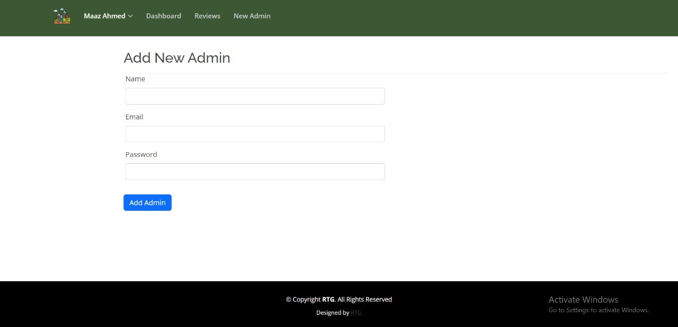

This page allows the already registered admin to add new members as admin to maintain the workforce of the agency in a smooth and efficient way.

**Functional Requirements**

Here are some functional requirements that RTG has considered:

**Website Design and User Experience**:

* The website should have a user-friendly and visually appealing design to attract and retain customers.
* It should have a responsive design that ensures the website is accessible and easy to use on multiple devices, including desktop computers, tablets, and smartphones.
* The site's navigation and structure should be clear and intuitive, allowing users to easily find the information and features they need.

**Login and Sign-up:**

* The customer should be able to either sign up or log in with his credentials to the website.
* The admin should be able to log in with his/her credentials to access the admin dashboard.

**Packages and their details:**

* The website should display travel packages in a clear and visually appealing way using images, descriptions, and detailed itineraries.

**Customization:**

* Customers should be able to customize their travel itineraries to suit their preferences and needs. This can include options such as selecting the type of vehicle, tour guide, destination, and rough estimate of the budget.

**Booking:**

* The website should have an online booking system that allows users to book travel packages.
* The customer should be able to add and delete his bookings and reservations.

**Confirmation Email:**

* The website should send a confirmation email to the customer to ensure booking is done by him/her.

**Reviews and ratings:**

* Customers should be able to read and write reviews and ratings of travel packages and services offered by the agency. This can help other customers make informed decisions and provide feedback to the agency on their experiences.

**Customer Support:**

* The website should have an FAQ section or help center that provides answers to common questions and issues.
* It should also have a contact form or contact information for users to get in touch with the agency for further assistance.

**Advertisements:**

* The website should support a variety of ad formats, such as banner ads, display ads, video ads, and native ads.
* The website should ensure that all advertisements comply with relevant laws and regulations, such as those related to privacy, data protection, and intellectual property.

**Newsletter and Explore Us:**

* The website should have a newsletter sign-up form that allows users to subscribe to receive updates and special offers from the agency.
* The website should have a blog or news section that provides travel-related information, tips, and inspiration to users. This can help the agency establish itself as a reliable source of information and keep customers engaged and interested.

**Admin Dashboard:**

* The admin is responsible for managing and tracking customer bookings and reservations.
* The admin should be able to delete fake reviews or reviews containing abuse.
* The admin should be able to approve the reservations.
* The admin should be able to register new admins.

**Non-Functional Requirements**

Here are some non-functional requirements that RTG has considered:

**Performance:**

The website should be fast and responsive, with minimal loading times and the ability to handle high levels of traffic.

**Reliability:**

The website should be stable and reliable, with minimal downtime and errors. This can include measures such as implementing redundant servers and backup systems to prevent data loss and monitoring the website's performance to identify and fix any issues that may arise.

**Security:**

The website should have robust security measures in place to protect sensitive customer data such as personal details and allow secure login and authentication processes. This can include measures such as encryption of sensitive data such as customer passwords so the administrator cannot see the registered customer’s password.

**Usability:**

The website should be easy to use and navigate, with a clear and intuitive layout and design. This can include features such as clear calls to action, accessible and consistent navigation, and appropriate use of color and typography.

**Compatibility:**

The website should be compatible with a range of browsers. This can include testing the website on different browsers and devices to ensure that it functions correctly and looks good on a variety of platforms.

**Maintenance:**

The website should have a system in place for maintaining and updating the website, including fixing bugs, adding new features, and ensuring that the website remains secure and up to date.

**Data management:**

The website should have a system for storing and managing customer data, including booking information, payment details, and personal information.

**Responsiveness:**

The website should be able to adapt to different screen sizes and devices. In the context of a tourism website, this is important because potential customers may be using a variety of devices, such as smartphones, tablets, laptops, and desktop computers, to access the website.

**Conclusion:**

The process of designing and developing a website for a travel agency involves a number of technical and creative skills, including HTML, CSS, and PHP coding, as well as design and user experience principles that are MVC as per Laravel. The website provides user-friendly, visually appealing, and easy to navigate experience in order to attract and retain clients. A booking and reservation system is the key feature of our travel website, which also ensures that it is secure and reliable. The website would reflect the brand and image of the travel agency, and would be integrated with the agency's overall marketing efforts.

Overall, developing a website for a travel agency required a combination of technical skills, such as coding and web development, as well as design and marketing expertise.